Name:

LINUX Assignments

**Exercise 1:**

Adding new user by GUI

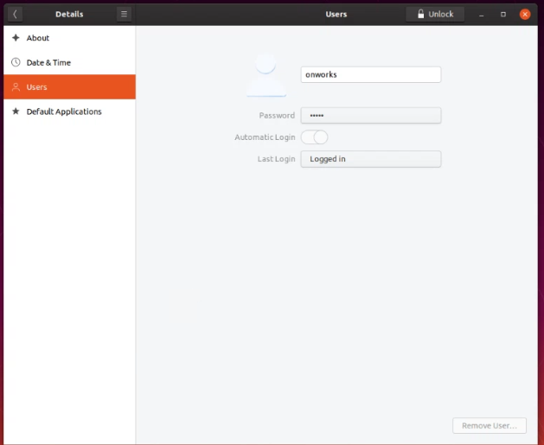

my user name is show here

Unlocking to add new user

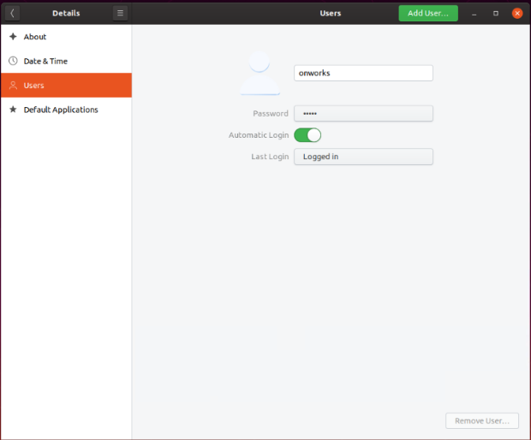

Account unlocked successfully

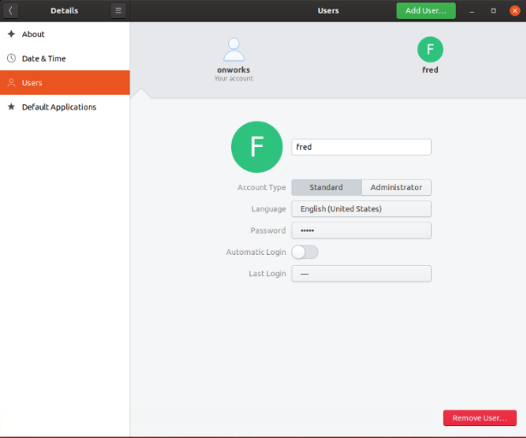

New user added



Second user added

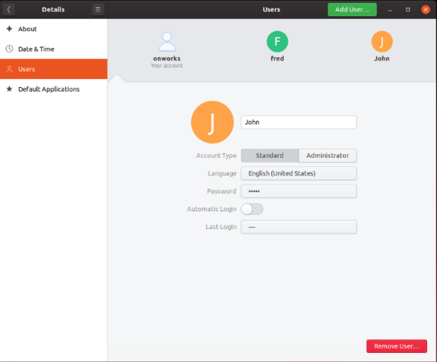

**Exercise 2:**

Running whoami command to show the user information



Using pwd to show the current working directory



**Exercise 3:**

Running man command to show manual for adduser



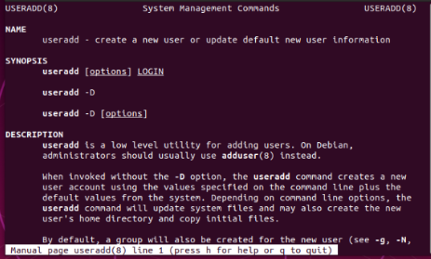

**Exercise 4:**

Echo to print any message



Use of echo with parameters

